Exp.No:33
33. Morphological operations based on OpenCV using Morphological Gradient technique.

Aim:
To perform the Morphological Gradient operation using OpenCV.
Procedure:
- Read the input image.
- Create a structuring element.
- Apply the morphological gradient.
- Display the original and gradient images.
- Save the output.
Program:
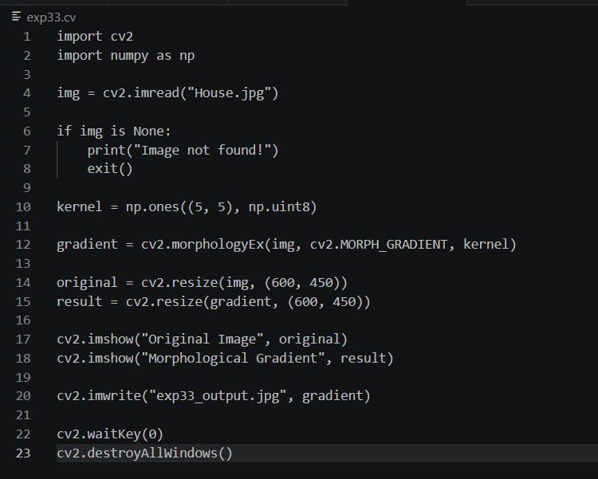

Input:


Output:
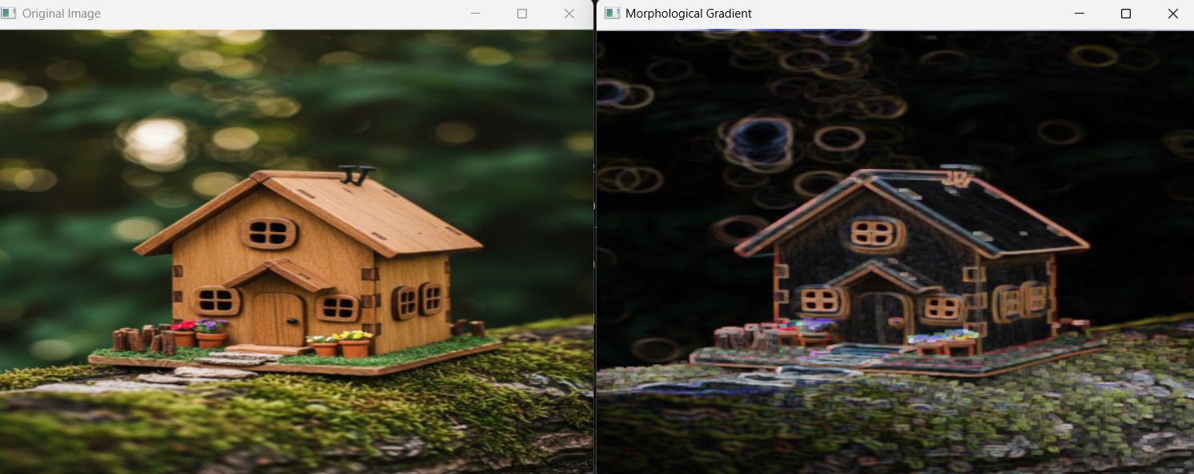

Result:
The morphological gradient was successfully obtained from the input image.

